4 August, 2026
Today’s topic –
- User management-
- Profile: it tells us the post, then we make many users for that profile.
Example: customer care, two users bunty and Babli. User story 1: create a user bunty and Babli under the profile customer care.
First, we will make profile of “customer care“ then will make 2 user bunty and Babli.

Step 1-
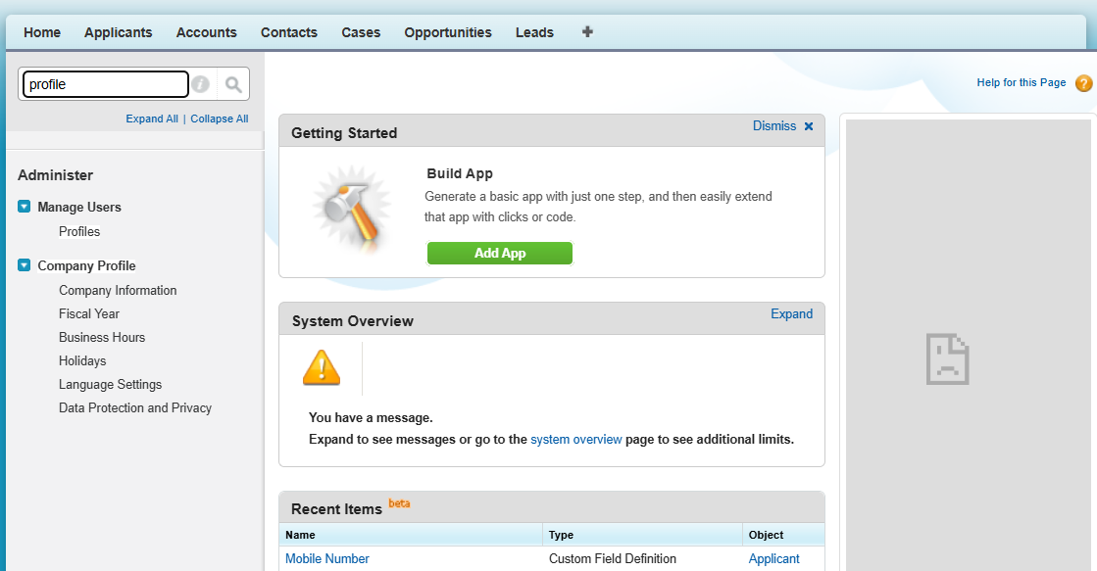

Step 2
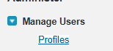

Step 3
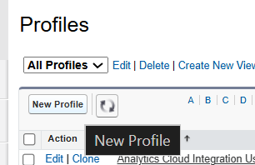

Step 4
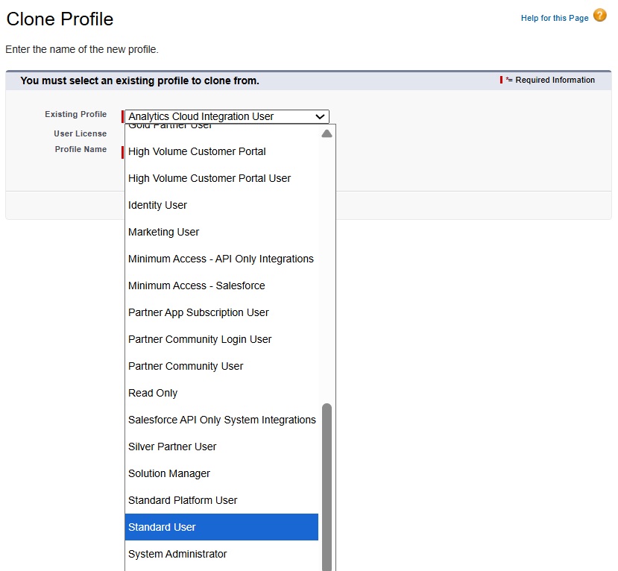

Step 5
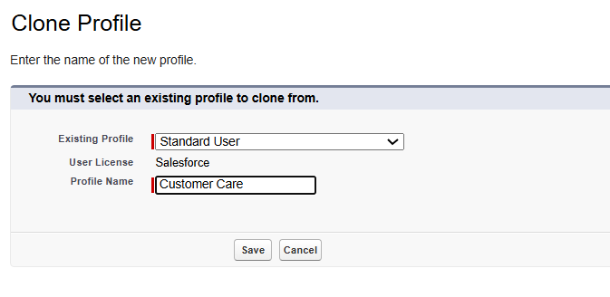
Step 6
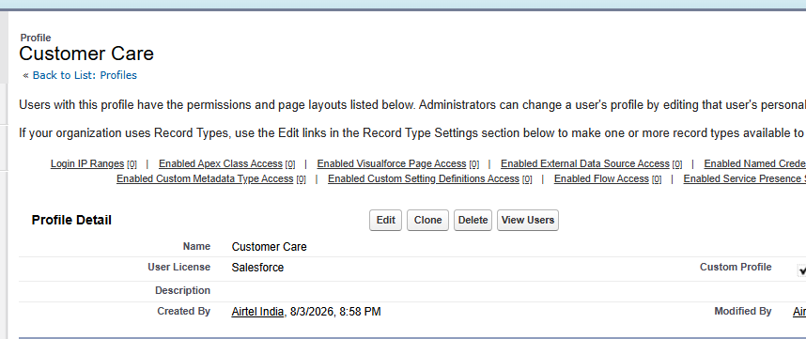

User :-

Step 1-
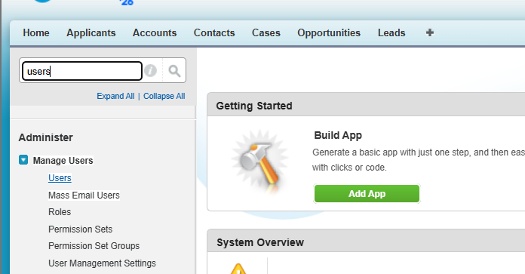

Step 2
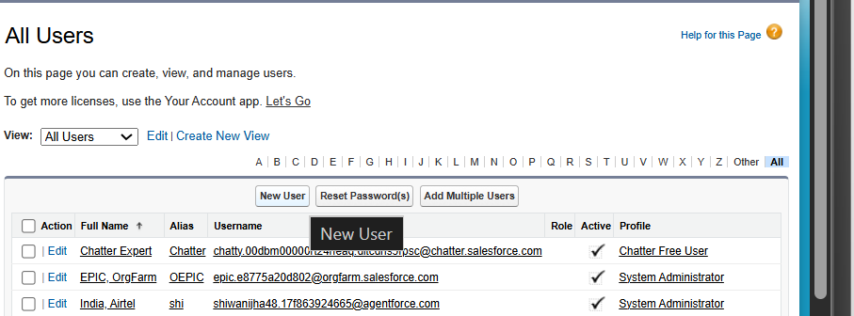

Step 3

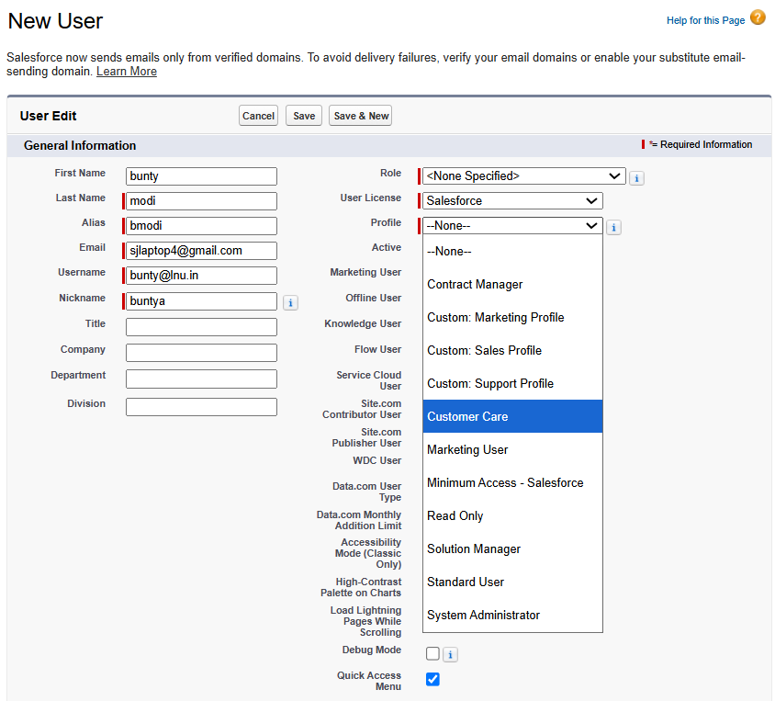

Step 4
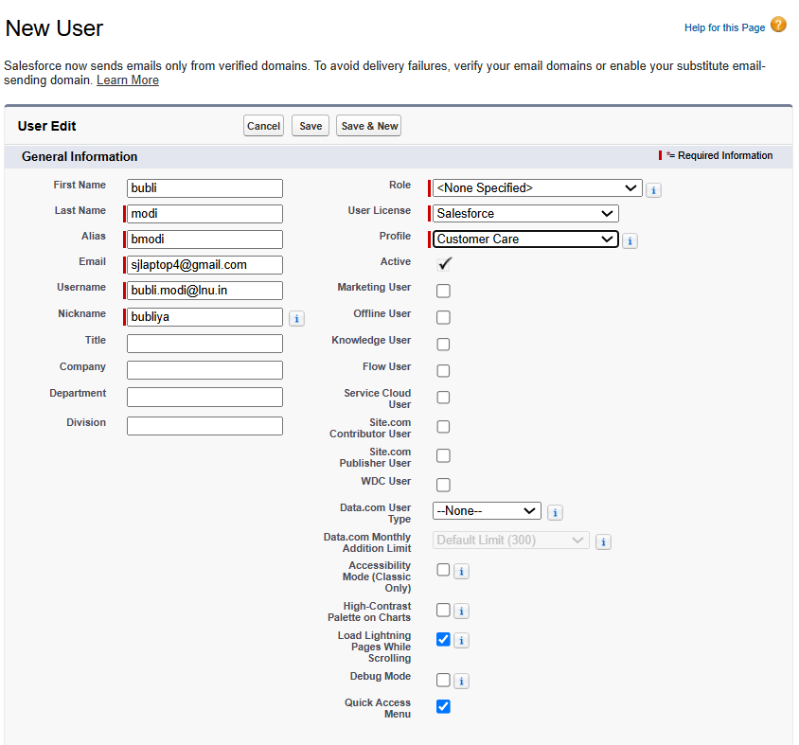

Step 5
There can only be 3 users active in free.
System administration, 2 users active at a time.
Can make many users but active only 2.

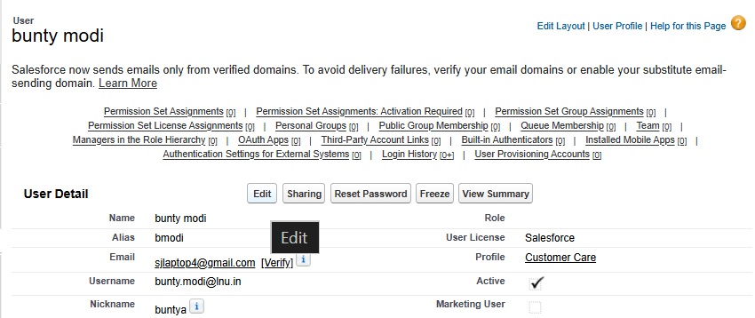

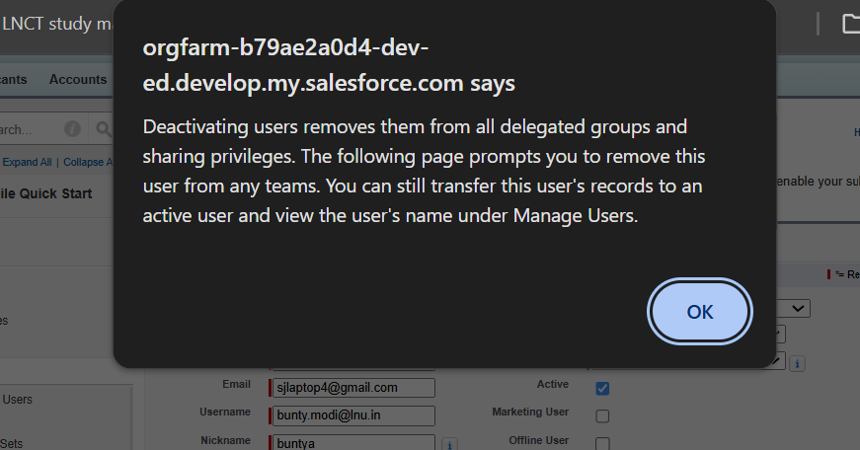

Active unchecked.
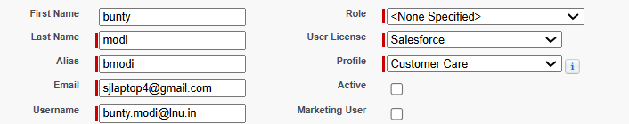

Bunty inactive
Bubli active

Validation rules
Object = table
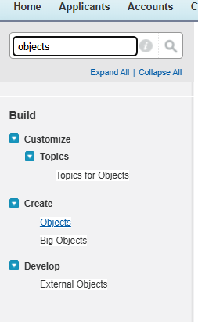
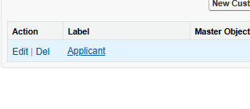
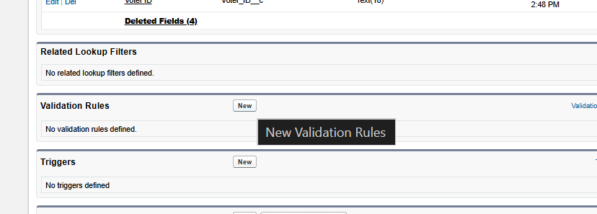

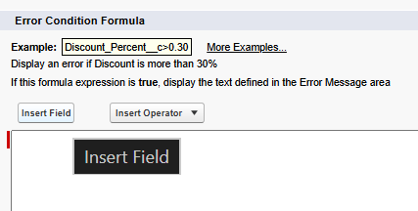

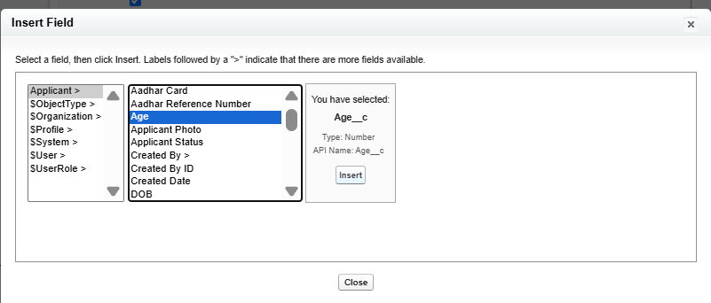
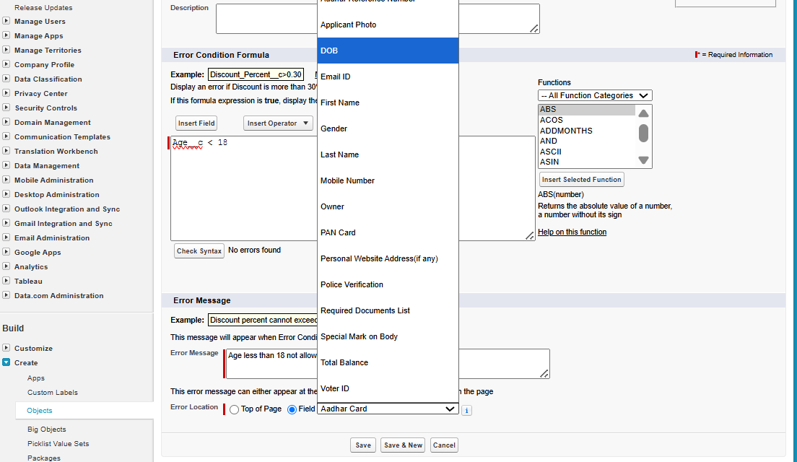

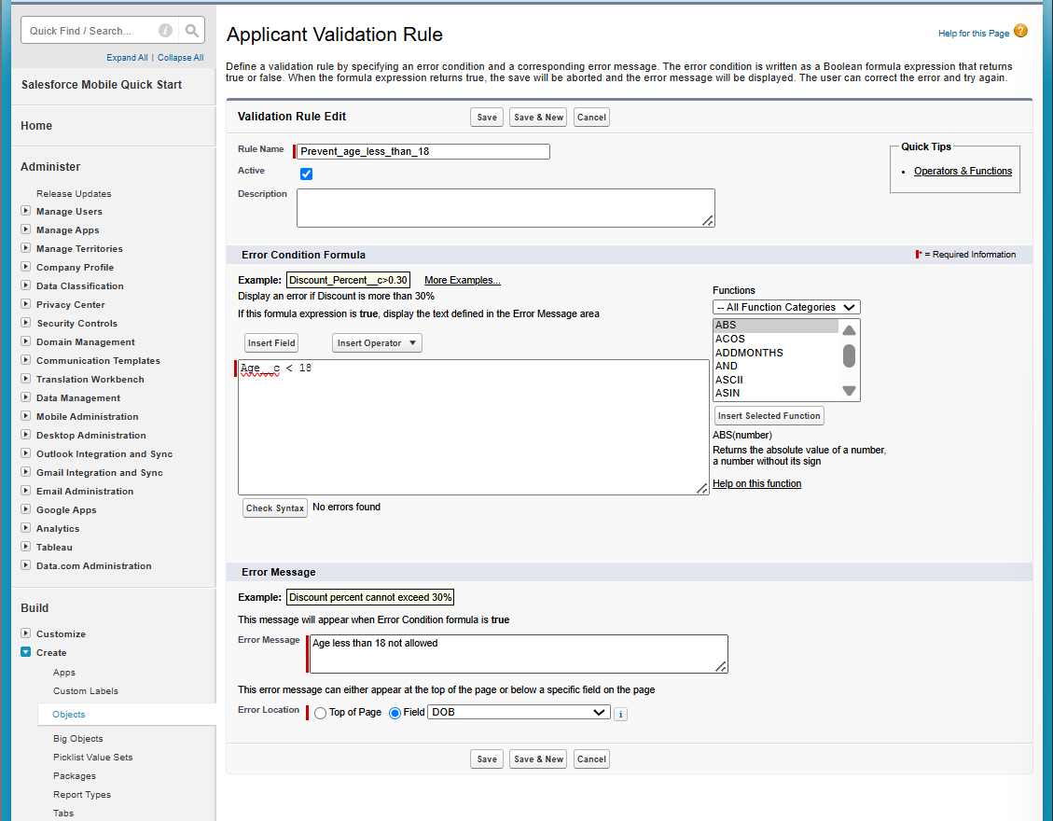

Result =
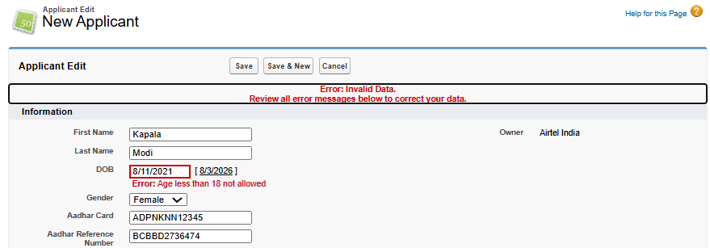

User story 3-
Create a vliation rule, prevent applicant if age 18 and genrder is male or female and not eligible for police verification
1 and 2 or 3 and 4
And (1, 4, or (2, 3))

Step 1
Search for applicant (object)
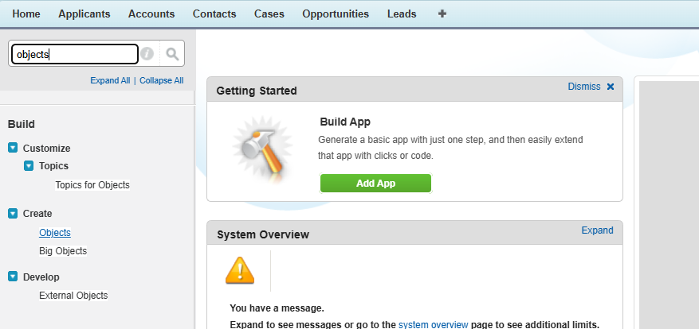
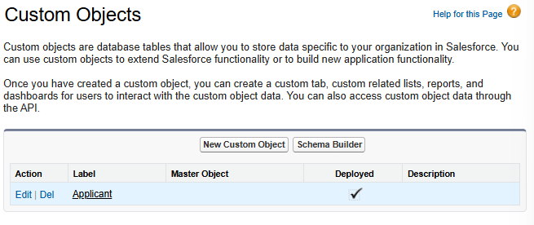

Step 3-
Click on validation rule – “new”
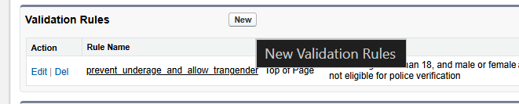
Create a new validation rule.

Step 4-
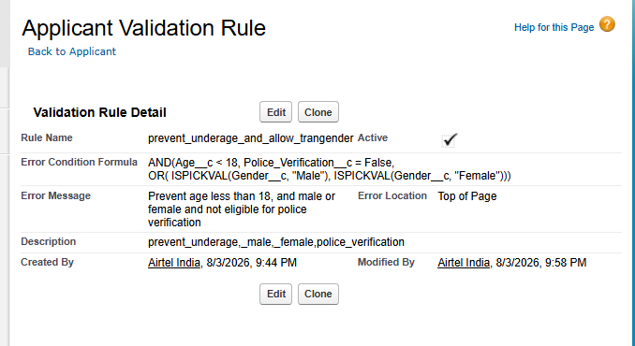
Code –
AND(Age__c < 18, Police_Verification__c = False,
OR( ISPICKVAL(Gender__c, "Male"), ISPICKVAL(Gender__c, "Female")))
Message –
Prevent age less than 18, and male or female and not eligible for police verification

Step – 5
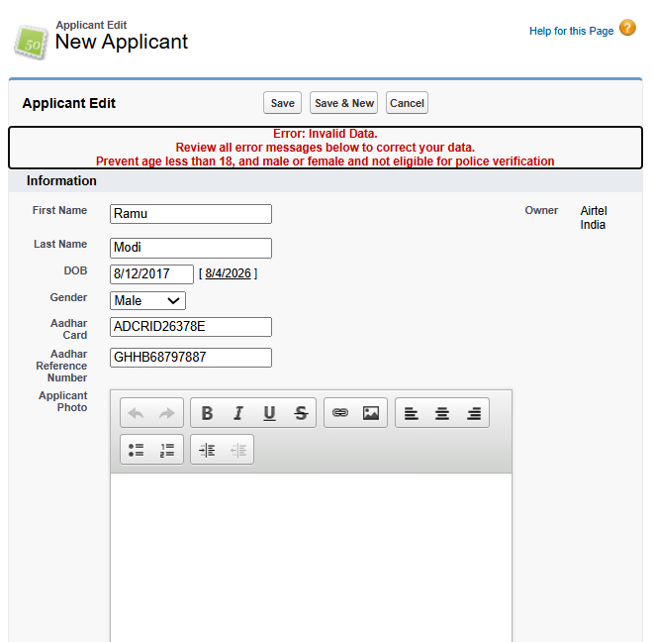

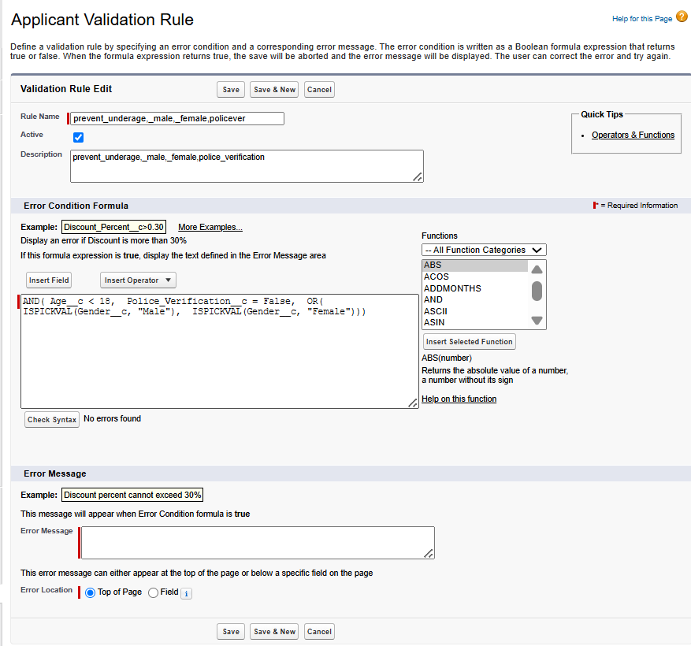

User story – 4
Assignmenet question-
create a validation rule on account object. prevent - i) account name starts with "d" and ii) account name type is "prospect" and iii) account rating is "hot" or cold" iv)account sla is gold. how to do this in salesforce.
Step 1
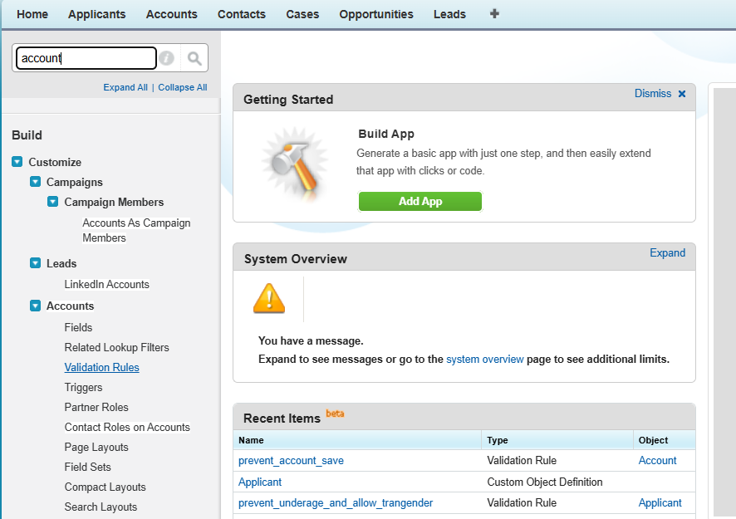

Step 2
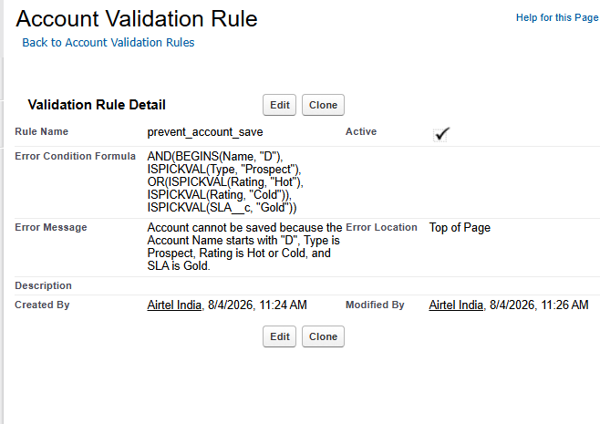
Code –
AND(BEGINS(Name, "D"),
ISPICKVAL(Type, "Prospect"),
OR(ISPICKVAL(Rating, "Hot"),
ISPICKVAL(Rating, "Cold")),
ISPICKVAL(SLA__c, "Gold"))
Eoor message-
Account cannot be saved because the Account Name starts with "D", Type is Prospect, Rating is Hot or Cold, and SLA is Gold.
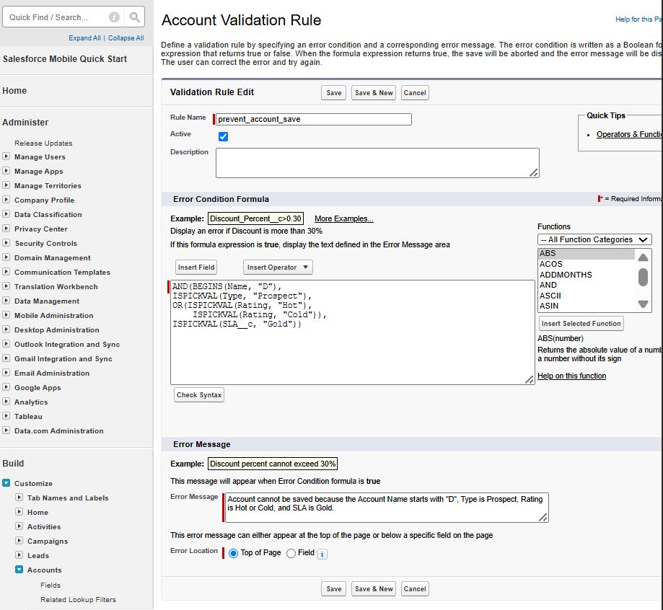

Step 4
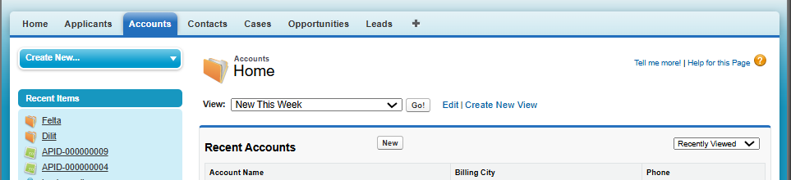
Step 5
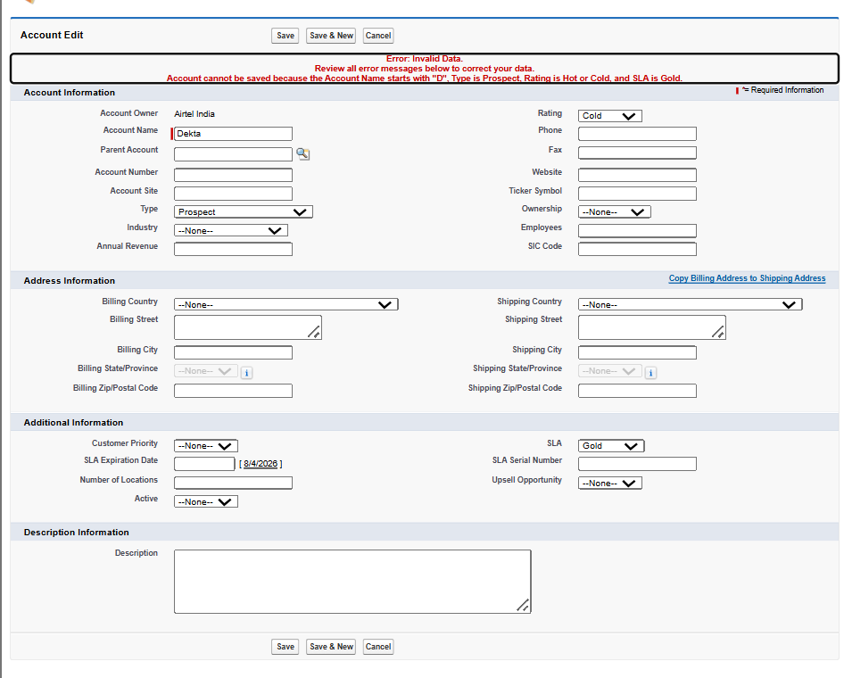
Step 6
